**AWS BUDGET**

To begin to use Amazon Web Services, a budget must be set to monitor our usage of resources.

These are steps I took to create a budget.

**Step 1:**

Navigate to the billing management console and choose budgets from the pane on the left or just search for AWS Budgets in the search bar.

Click on create budget.

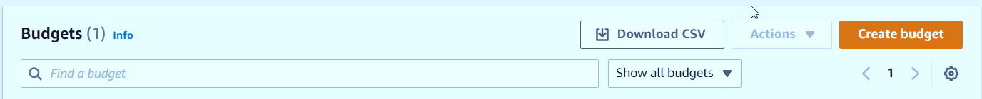

**Step 2: Choose budget type and set your Budget**

Clicking on Create budget takes you to a page with steps on going about the budget creation.

There are many budget types like Reservations Budget, Usage budget. But for this project, I chose cost budget.

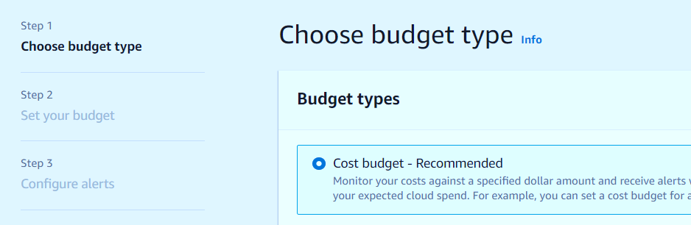

The next thing as shown on the left is to set the budget. On this page, there are 2 forms that will be filled.

1. Budget Name

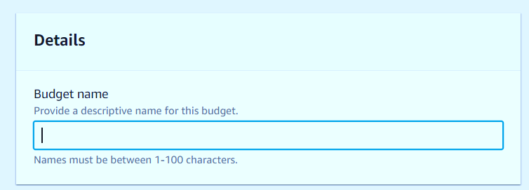

1. Budget amount

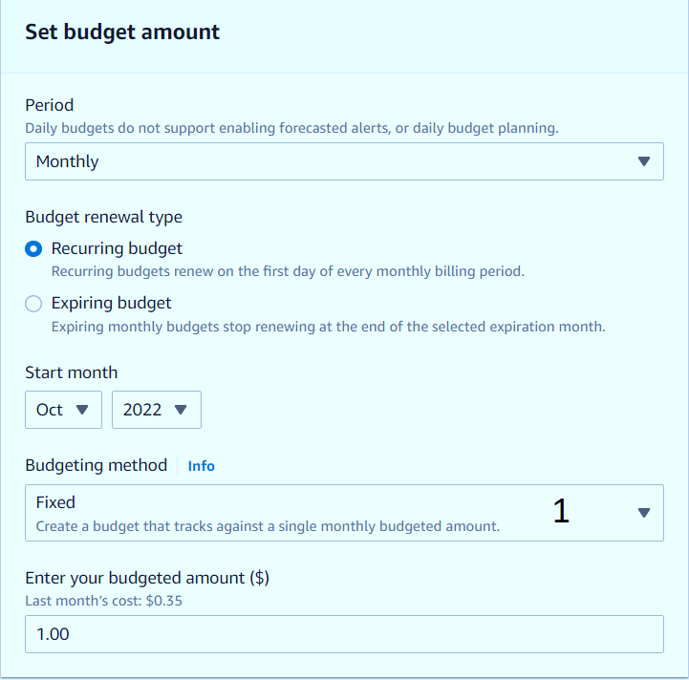

Budgeting method (1) has 3 options users can choose from.

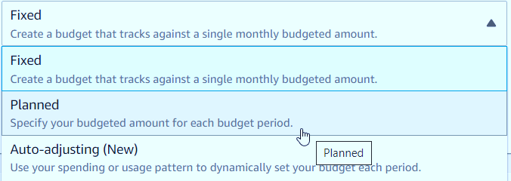

**Step 3: Configuring Alerts**

Add an alert threshold

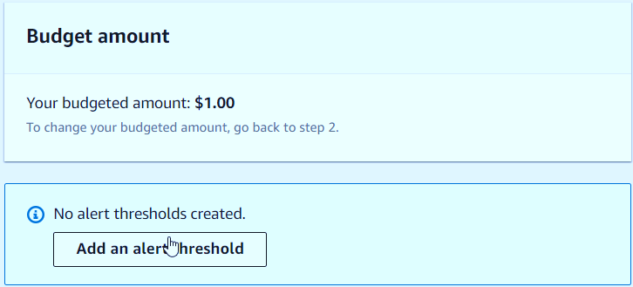

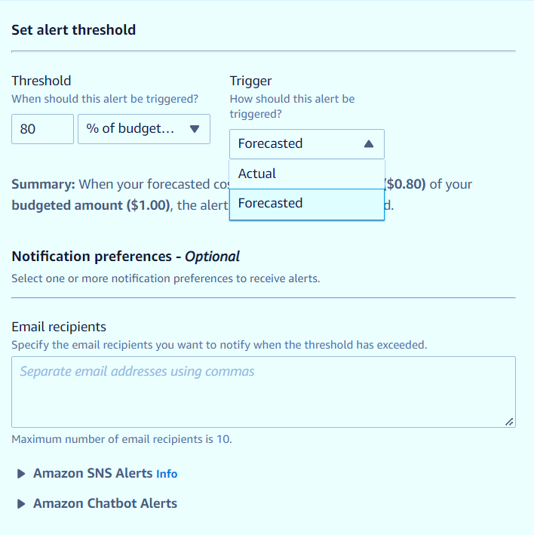

There you chose to either trigger the alert when actual cost exceeds threshold or when forecasted cost exceed threshold.

**Step 4: Attach Actions**

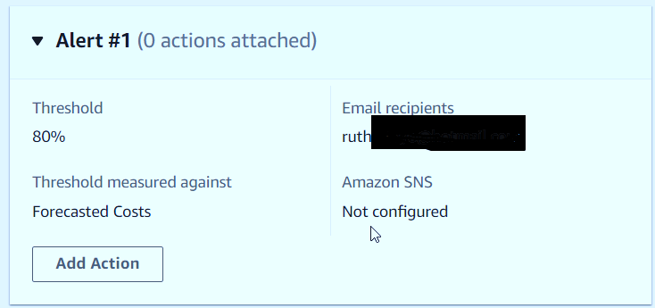

To add what action to be taken when the threshold is reached, an IAM role is needed

I manually created a new IAM role, granting the role permission to take actions.

First, Create role

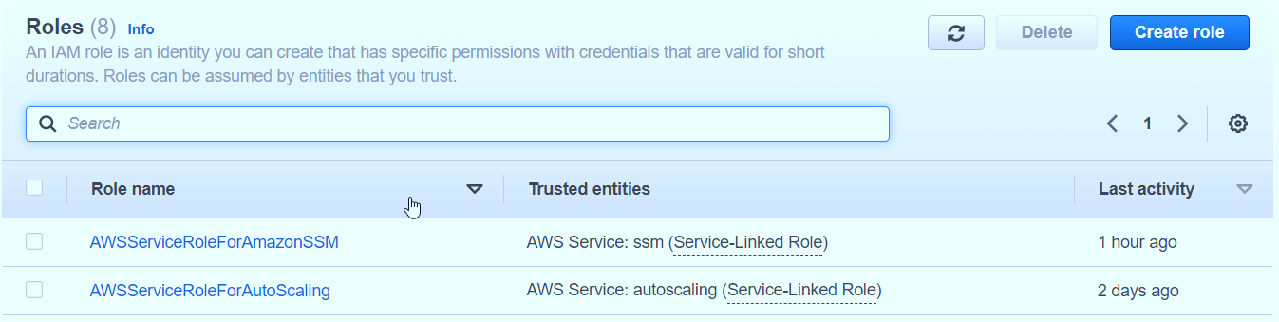

Next: Choose Budget as a use case.

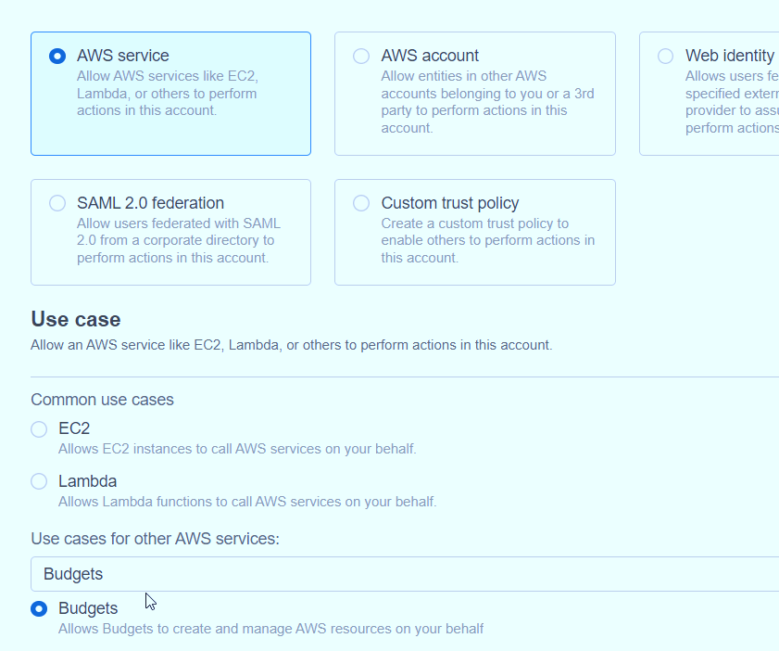

Next, add permission

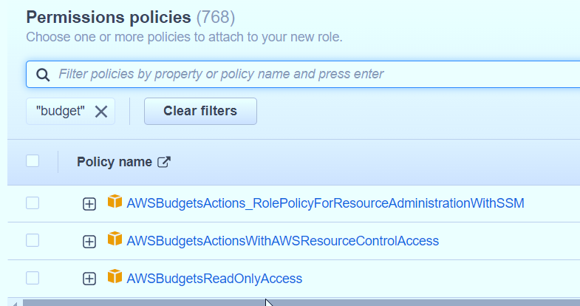

I chose the second permission policy as it was the policy the IAM role needed.

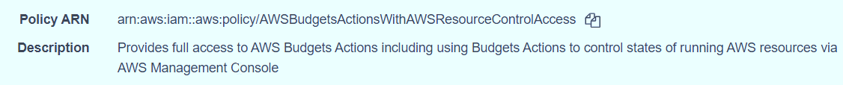

Finally, we give the IAM role a name, review and then create the role.

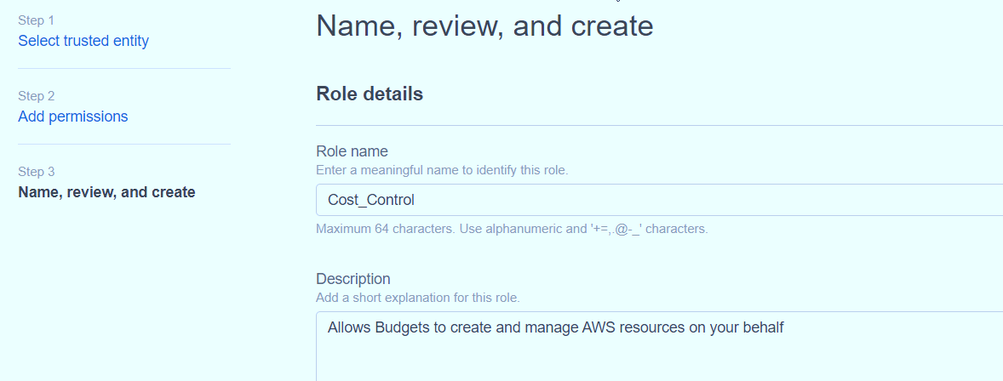

Back to the budgeting page, we now need to choose what action to be apply

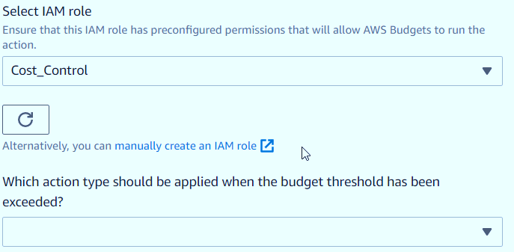

A, B or C? For this lab we chose C

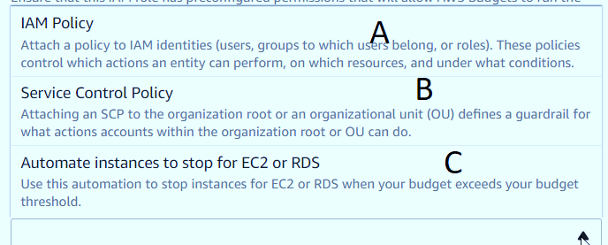

Finally, we choose the region, instances if they are more than 1 and **create the budget**

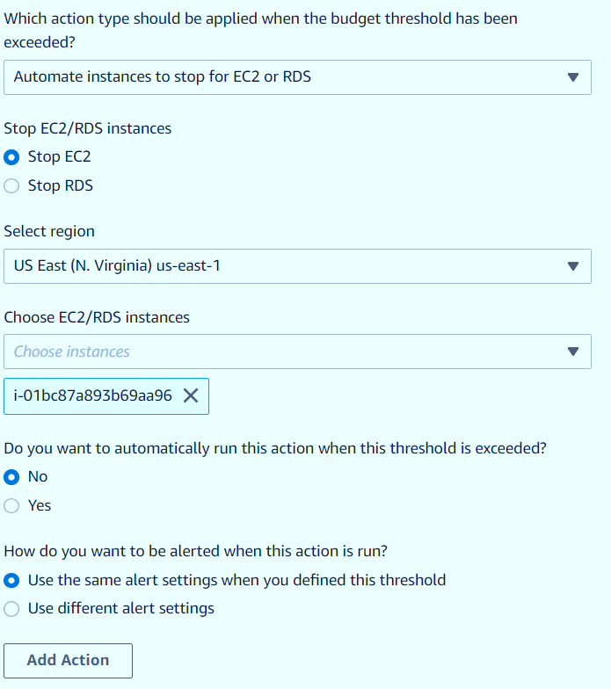

**Success Message**

